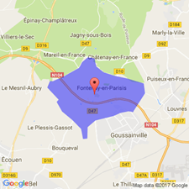[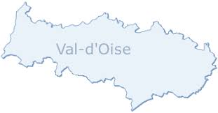](http://www.google.fr/url?sa=i&rct=j&q=&esrc=s&source=images&cd=&cad=rja&uact=8&ved=2ahUKEwiIufCS-ZLgAhVCrxoKHUyMCFEQjRx6BAgBEAU&url=/url?sa%3Di%26rct%3Dj%26q%3D%26esrc%3Ds%26source%3Dimages%26cd%3D%26ved%3D%26url%3Dhttps://www.telecartegrise.com/annuaire-carte-grise/professionnels_habilites/departements/Val-d-Oise-95/%26psig%3DAOvVaw1tpxOM4YoQMMIAmOBMvCYZ%26ust%3D1548849622542729&psig=AOvVaw1tpxOM4YoQMMIAmOBMvCYZ&ust=1548849622542729)

[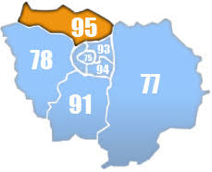](http://www.google.fr/url?sa=i&rct=j&q=&esrc=s&source=images&cd=&ved=2ahUKEwiYzZWd-ZLgAhUjz4UKHRmEAWAQjRx6BAgBEAU&url=http://www.huissierweb.com/blog/huissier-95-val-doise/&psig=AOvVaw1tpxOM4YoQMMIAmOBMvCYZ&ust=1548849622542729) [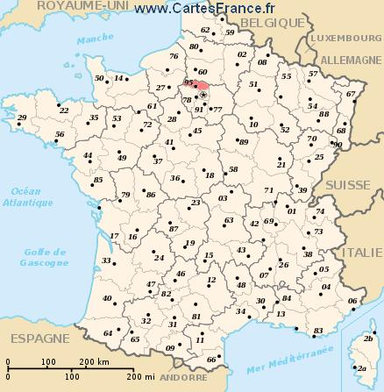](http://www.google.fr/url?sa=i&rct=j&q=&esrc=s&source=images&cd=&cad=rja&uact=8&ved=2ahUKEwiXrKae-pLgAhUI1hoKHe5zDzIQjRx6BAgBEAU&url=http://www.cartesfrance.fr/carte-france-departement/carte-departement-Val-D-Oise.html&psig=AOvVaw2WmjuYtaAfsYVzQACwYUo6&ust=1548850015839327)

[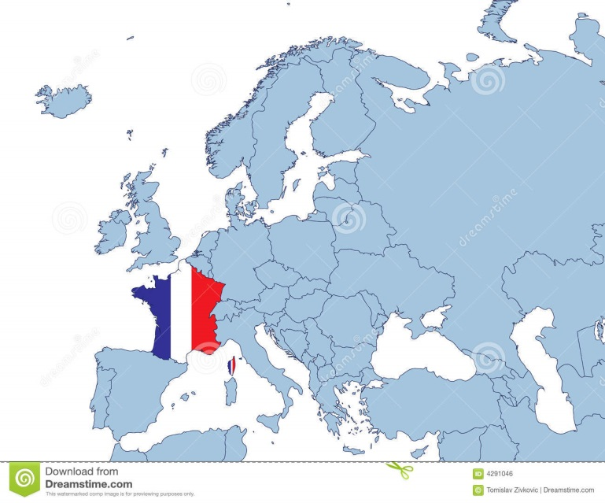](https://www.google.fr/url?sa=i&rct=j&q=&esrc=s&source=images&cd=&cad=rja&uact=8&ved=2ahUKEwi79ry5-pLgAhWCz4UKHW_wBvkQjRx6BAgBEAU&url=https://fr.dreamstime.com/image-libre-de-droits-la-france-sur-la-carte-de-l-europe-image4291046&psig=AOvVaw16wcgGgMQGSgMwd_Rfb_jk&ust=1548850102691666)